7th period Algebra Email: rmanning@vernonia.k12.or.us
Mrs. Manning
Description: The content of this course builds the foundation for success in all further math studies!
Integrity: All school policies for academic integrity apply to this course. Manage your reputation with care.
Electronics: We need to learn how to manage our attention. Electronics may not be out during instructional time. Students who can’t manage their attention need to leave their phone at home or in the phone jail to avoid having it turned into the office.
Materials: Show up daily, on time, and ready with: paper, pens, pencils, interactive notebook, binder, planner and your text. Any items left in my room will be donated to a needy student.
Grading:
- Do not rely on extra credit. It will rarely be made available.
- Grades come in three sizes: big (exams and interactive journal), medium (tests and assignment checks), and small (daily work).
- Late work will be accepted within reason for excused absences only, but the grade may be reduced.
- Assignments should be written legibly and properly labeled (Name and Student Number. Date. Period. Assignment.)
- Grading percentages: 100-90% = A, 89-80% = B, 79-70% = C, 69-60% = D, and <60% is an F

Make-up Work: All missed assignments can be submitted by an agreed upon date for excused absences. You are responsible for turning in late work and getting missed assignments. Athletes: If you are at school, it is expected that you turn in your homework and get the day’s assignments before you leave. Check out assignment calendar on my webpage often! This is a great place to check and see what was missed in class.
Webpage: It is my goal to update my webpage before I leave school. This is a good place to see what happened in class. Please also be checking with your homework partner in class.
Go to the Vernonia School District’s website: www.vernonia.k12.or.us.  Go to the Student tab’s dropdown menu and click Staff Web Pages. | On the left-hand side of the Staff Web Pages page, click on Manning. | Assignment calendar is on the main page.
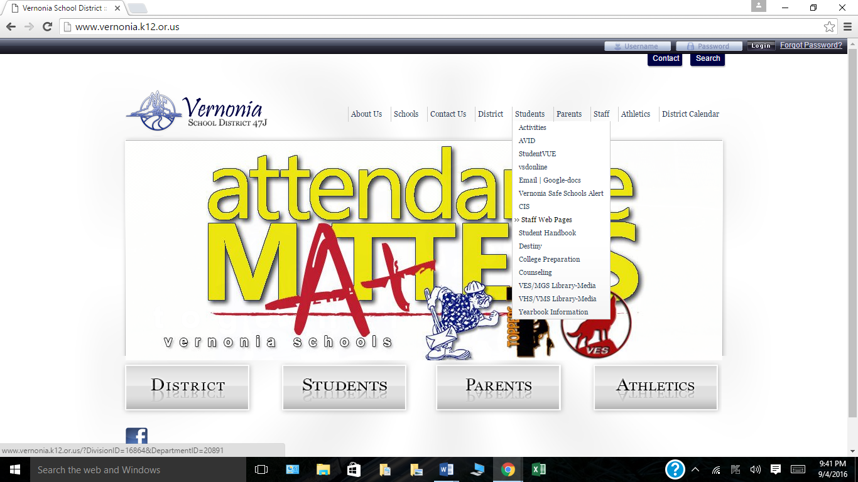 | 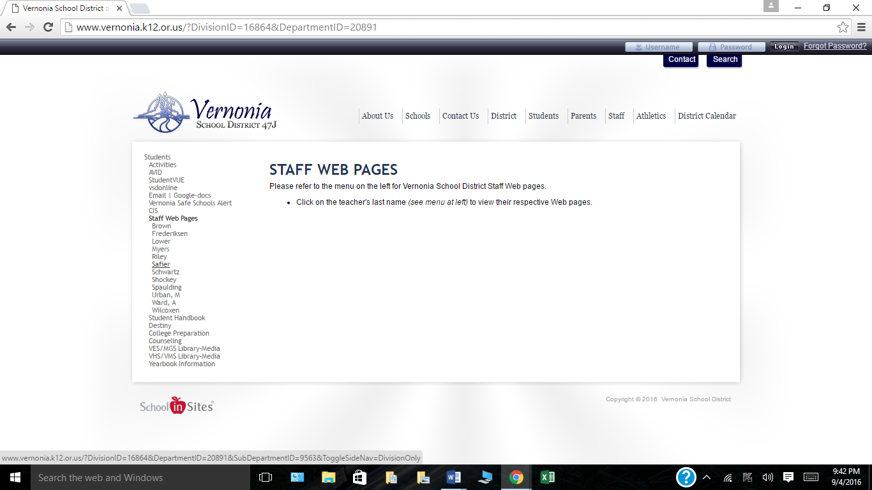 | 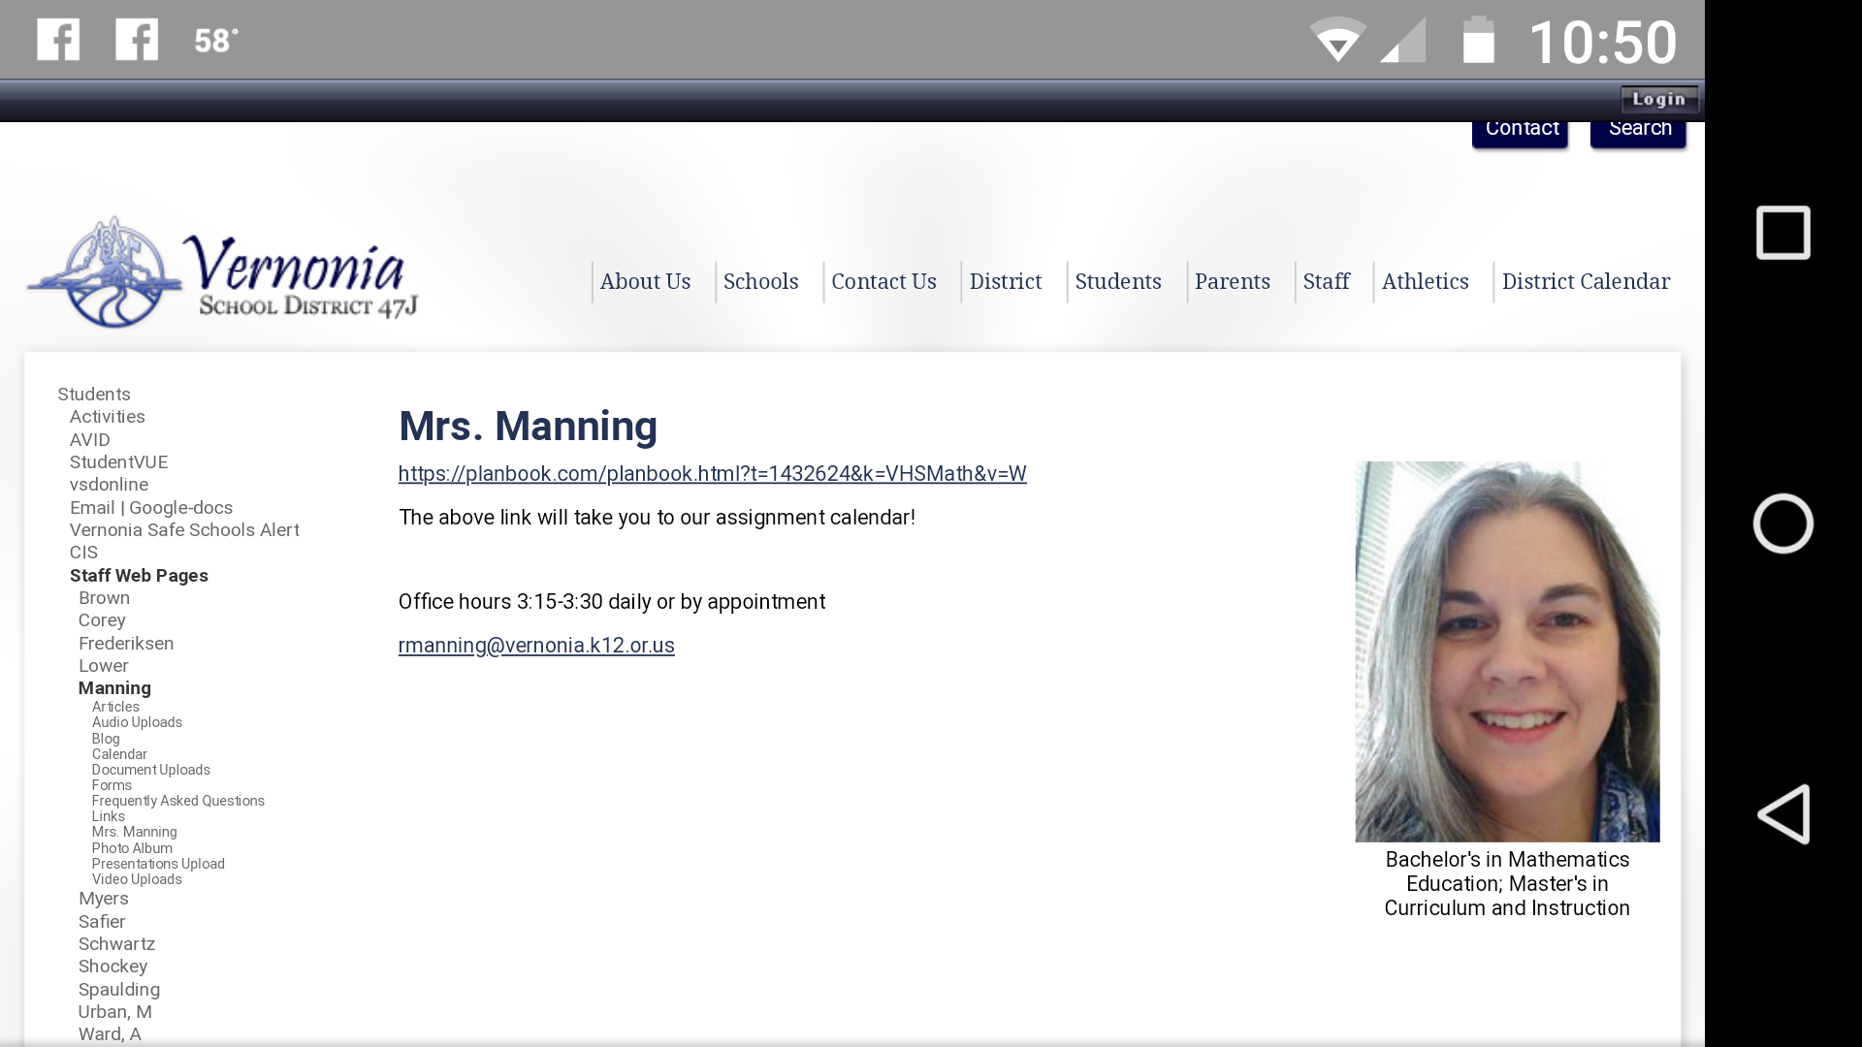

Attendance: All school policies apply. You must be present to learn!
Responsibility: We will discuss this more in class but essentially:
  - Be Safe
  - Be Responsible
  - Be Respectful

Remind: I am using the app Remind for communication. Students, parents, and guardians may sign up for them.
Participation IS NOT mandatory, but encouraged. I will not see your phone number, just your name (which you enter). You will not see my phone number.
In order to join:
Text: 81010
Message: @mathvhs
Communication/support: I encourage you to email or use remind to message me at your convenience. I will respond as soon as I am available. Students may also message me pictures of math problems if they are struggling at any time. There will be times that I don’t have service or am unavailable but, again, I will respond with help as soon as possible. Students are also encouraged to discuss their learning with classmates or access links for assistance on our assignment calendar. One of my major goals is for each student to become an independent, life-long learner. This means that help is often given by asking leading questions or asking a student where they can find similar problems in their notes or text. It is very important for all students to know how to access reliable information to support their learning.
Homework/practice: I may or may not assign homework but I do expect students to spend about 30 (never more than 45) minutes every day practicing math problems or interacting with their notes that they took during class. Daily practice and review is absolutely necessary to gain new skills and knowledge. If your student is not doing homework and you are not pleased with their progress, this is the first step that needs to be taken outside of class. I would also appreciate an email so that I can let you know what I am observing in class.

Mrs. Manning
rmanning@vernonia.k12.or.us

Algebra Student Name________________________________________
(Print Name)

Syllabus Review

Thank you for taking the time to read this syllabus.

_______________________________________________ _____________________
Parent Signature Date
(For Syllabus Review)

_______________________________________________ _____________________
Student Signature Date
(Syllabus Signature)

